Primary Health Care Department Report 2013/14

1. GENERAL OBSERVATIONS
In the year 2013/2014 (the financial year runs from July to June) the Primary Health Care (PHC) department continued to offer integrated services in its six areas of intervention, which include Mother and Child Health, Nutrition, Environmental Health, HIV/AIDS prevention, treatment and care, Palliative care and Orphan care.

2. STAFFING
The department had 22 Members of staff during this reporting period. This include four community health nurses, four nursing midwifery technicians, two senior enrolled nurses, one Environmental Health Officer, one Senior Health Assistant with 68 health surveillance assistants who are civil servants. The HTC department has 5 counsellors and one youth volunteer counsellor while nutrition and orphan care has one agriculture field assistant, and three home craft workers. The youth program was run by a youth centre manager who is also an HIV/AIDs Coordinator. We had one resignation, of the PHC Coordinator, who was replaced by an Environmental Health Officer, so there is currently one vacancy for an Environmental Health Officer.

3. CATCHMENT AREA
Mulanje Mission catchment area has a total of 72 villages and a population of about 84197; these are manned by Health Surveillance Assistants (HSAs). Most HSAs have one village except a few who have two villages each. The catchment area is divided into two, Mulanje Mission Hospital area which has 42 villages and Chisitu Health Centre area which has 30. This number of villages is going to grow because some big villages have been divided by government.

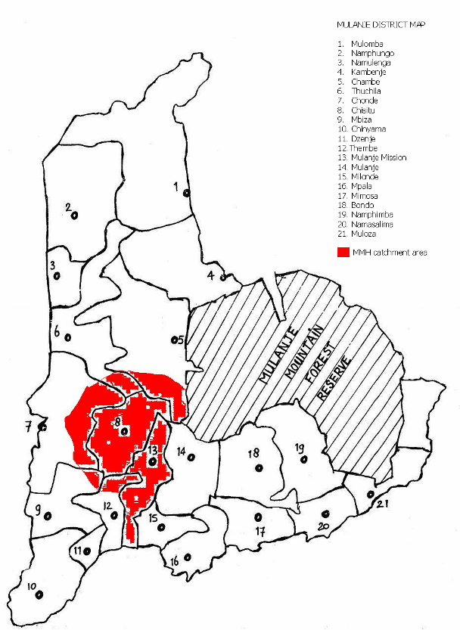

4. DEMOGRAPHIC DATA
The total population for Mulanje Mission Hospital area is 84197 with 19112 households, of which 83% have access to safe water and 71% have pit latrines. The total number of under fives is 11,967

5. ENVIRONMENTAL HEALTH
During the year 2013/ 2014 the Environmental Health staff continued assisting to improve and maintain a good state of health through the promotion of:

- Good sanitation at household level.
H.S.As and community volunteers take a leading role in this task to make sure sanitary facilities are present at household level
- Growth monitoring of children below the age of five years.
This is a very important exercise to prevent child deaths due to malnutrition because malnutrition cases are identified early.
- Information; health education by volunteers and HSA in order to create awareness of health issues.
- Indoor residual spraying
Indoor residual spraying has helped our community to experience less cases of malaria, IRS started in 2012 with 4 villages and in 2013 we increased to 22 villages, we are expecting to spray more villages this year. When we started, malaria cases were slightly above 10 per 100 populations but now are below this level.
- Other disease control measures eg mass administration of praziquantel to combat schistosomiasis in school children..

6. GROWTH MONITORING
The Health Surveillance Assistants continued during the year providing the following services in all the 10 growth monitoring centres around Mulanje Mission Hospital and the static clinic where they do the following activities:

- Weighing of children under the age of five

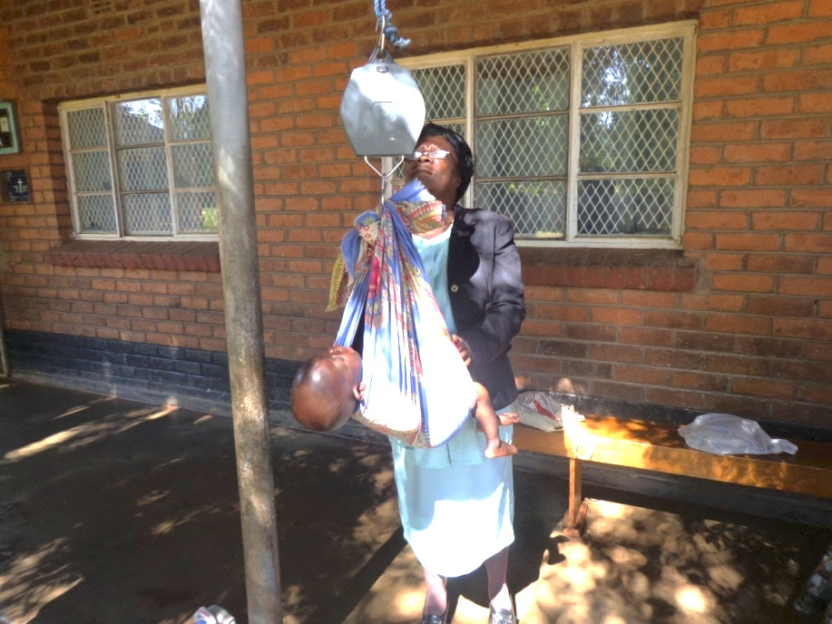
Figure 1 PHC nurse weighing a child
- Screening of children for various diseases and other health related problems.
- Immunization of children against six killer diseases.
- Referral of children with health problems to the hospital
- Health education on various health issues.

 | NRU |  | SUPPLEMENTARY  FEEDING
GROWTH MONITORING (at NRU) | 2012-13 | 2013-14 | 2012-13 | 2013-14
Normal weight | 64 | 43 | 134 | 138
Malnourished | 70 | 56 | 152 | 176
Total | 134 | 99 | 286 | 314
% Malnourished | 52 | 57 | 53 | 56
Apart from the above routine activities, the department also had a child health week where children were given Vitamin A, albendazole and praziquantel. Coverage during this week was above 80%. We also had a week where we were administering mectizan and albendazole to control River blindness (onchocerciasis).

Outreach clinics

We have 12 outreach clinics where we do under five children screening, weighing and immunisation; we also do antenatal care, HIV testing, ART and health education. We are fortunate to have proper clinic structures which help us to carry out all these activities in the community.

7. DISEASE SURVEILLANCE AND CONTROL

In our quest to check and control diseases in our catchment area, the PHC department has more than one thousand health volunteers. These volunteers report to HSAs for mentorship. Whenever we have an outbreak, it is quickly reported by these volunteers. We make sure that all our volunteers are trained and know what they are doing when working in their communities.
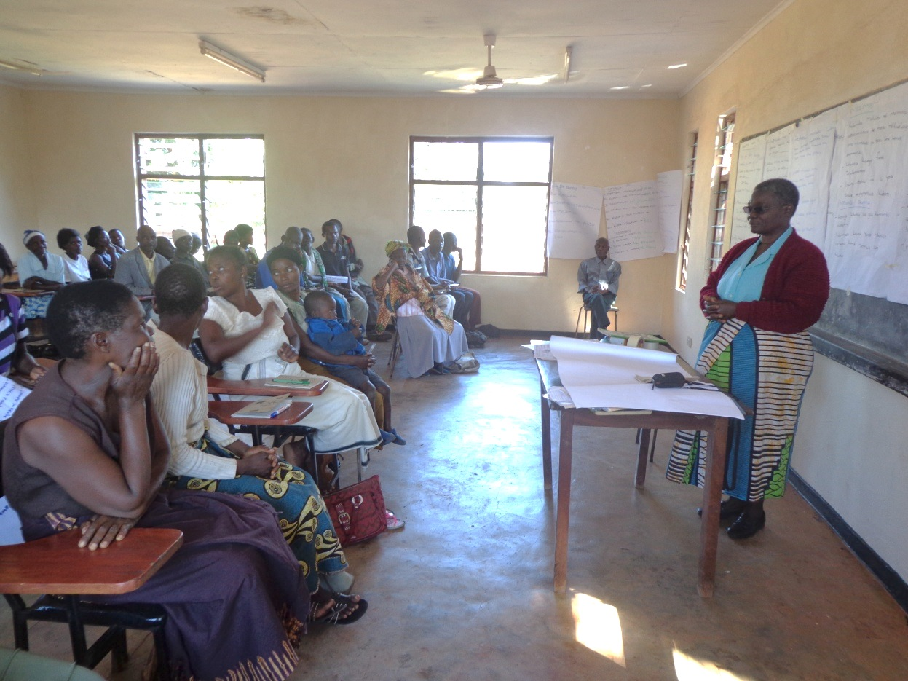

Figure 2 Community Nurse training some volunteers
The biggest activity this year was malaria control through Indoor residual spraying. When we compared sprayed and unsprayed villages, it showed that this intervention is working because random blood testing for malaria parasites showed that in unsprayed villages 70% were positive, while only 20% were positive in sprayed villages.

8. MOTHER AND CHILD HEALTH

A total of 27,305 children less than 5 years were screened during the reporting year. Of these, 26,002 had normal weight and 1,303 (4.8%) were under weight. Table below shows immunization figures.

IMMUNIZATION | 2013-2014
BCG | 2682
DPT – HEP B and HIB | 6462
POLIO | 2245
MEASLES | 2449
PCV | 6733
Rota | 4642

We saw good coverage on the number of fully immunized children because out of the targeted 2465, 2437 were fully immunized which gives us a 99% coverage.
The Table below shows the number of women receiving doses of TTV;

TETANUS TOXOID
DOSE
TTV 1 | 1735
TTV2 | 1296
TTV 3 | 416
TTV 4 | 215
TTV 5 | 121

ANTENATAL CARE

ANTENATAL  (new visits) | 2013-2014 | 2012-2013
In first trimester | 240 | 236
Total new antenatal visits | 2600 | 2678

9. FAMILY PLANNING

METHOD
CONDOMS | 6,085
ORAL CONTRACEPTIVES | 660
DEPO-PROVERA | 14,072
IUCD | 4
Inplant insertions | 101
BTL | 104

10. SCHOOL HEALTH PROGRAMME

The School Health Programme provides services for primary school aged children for the purpose of optimizing their health status in order to facilitate learning. It involves collaboration between school authorities, teachers and the health team.
We conducted school health programmes with the following objectives:
- To facilitates creation of a healthy environment conducive to learning.
- To provide adequate support systems for promoting healthy life styles.
- To make essential health services appropriate to school aged children more accessible and available.
The activities were conducted in three areas namely:
- Social environment.
- External environment of the school premises and the surroundings
- Health assessment of pupils.
We managed to reach 6 schools as planned, listed below;

1. CHIBATHI PRIMARY SCHOOL.
Established in 1935 by the Roman Catholic Church under Blantyre Archdiocese.
The school is under Ulongwe Teachers Development Centre Zone.
The school is surrounded by four villages: Makwale, Samson, Tambala and Lowa in the Traditional Authourity Mabuka. The school enrolment for the fiscal year 2013 – 2014 was 693 pupils where by 417 are male pupils and 276 are female pupils. Total number of teachers is 13 of which 10 are females and 3 are male teachers.

2. KANG’OMA PRIMARY SCHOOL.
The school was established in 1952 under Blantyre Arcdiocese. The school name was derived from the name of the village where the school is located. The school is under Ulongwe Teachers Development Centre Zone.
The school is surrounded by six villages namely: kang’oma, Bwanali, Majawa, Misanjo , Bokosi and Wasi in the Traditional Authourity Mabuka. The school enrolment for the fiscal year 2013 -2014 was 805 of which 382 are boys and 423 are girl pupils. The school has got 11 teachers in total of which 8 are males and 3 are females.

3. KHAYA PRIMARY SCHOOL
The school was built under CCAP Blantyre Synod and is under Ulongwe Teachers Development Centre Zone.
The school is surrounded by six villages namely: Mmina, Sapuwa, Mataka, Manyangala, Nakutho and Bwanali in the Traditional Authourity Chikumbu. The school enrolment for the fiscal year 2013 -2014 was 2180 pupils of which 1099 are boys and 1081 are girls. The school has got 11 teachers in total of which 6 are males and 5 are females.

4. KANJEDZA PRIMARY SCHOOL
The school was built by the government through Mulanje District Council and is under Ulongwe Teachers Development Centre Zone.The school is surrounded by four villages namely: Salamba, Wasi, Mamera, and Sembezi in Traditional Authourity Mabuka. The school enrolment for the fiscal year 2013 -2014 was 819 of which 345 are boys and 474 are girls. The school has got 10 teachers in total of which 7 are females and 3 are males.

5. NGOLOWERA PRIMARY SCHOOL
The school was established in the year 2000 by Catholic Church under Blantyre Arcdiocese and the government through Mulanje District Council.The school is under Ulongwe Teachers Development Centre Zone. It is surrounded by three villages namely; Ngolowera, Namatingwi and Kuthanguwo in Traditional Authourity Chikumbu.The school enrolment for the fiscal year 2013 -2014 is 635 of which 327 are boys and 308 are girls.
The school has got 9 teachers in total of which 6 are males and 3 are females.

6. SIKOYA PRIMARY SCHOOL
The school was established by the CCAP Blantyre Synod in 1985.The school is under Ulongwe Teachers Development Centre Zone.It is surrounded by five villages namely: Sikoya, Gilbert,Robeni,Nkumbi and Waluma in Traditional Authourity Chikumbu. The school enrolment for the fiscal year 2013 -2014 was 1594 of which 819 are boys and 775 are girls.The school has got 12 teachers in total of which 8 are males and 4 are females.

ACHIEVEMENTS and STRENGTHS OF THESE SCHOOLS
- Parent and Teachers Association members are active in all primary schools.
- School blocks are permanent with iron sheets.
- Availability of water source within the school premises.
- Availability of toilets for girls and boys and teachers separately.
- Availability of refuse disposal area.
- Availability of recreation area for both boys and girls.
- Presence of nutritional program.
- Good relationship between teachers, parents and pupils.
- General hygiene.
- Pupils are able to put on school uniform.
- Availability of school market.
- The school has norms and values, vision and mission statements.
- They have curriculum designed in such a way that it stimulates critical abilities and thinking.
- The schools have good security.
- They have low school dropout rates
- Health assessment (head to toe examination) was done, all standard one pupils were assessed.
CHALLENGES FOUND DURING SCHOOL HEALTH ACTIVITIES
- They do not have enough desks for all classes.
- They do not have school library, books are kept in headmasters office.
- They do not have enough teachers or enough learning materials.
- Some foods that are sold in the school market are not covered
- Some schools have few female teachers who can be models to girls.
- Toilets are not enough, ideal ratio of girls toilets is 1 to 20 whilst boys is 1 toilet to 25 pupils.
- The toilets have no doors hence no privacy.
- There are no hand washing facilities at the toilets, bad smell from toilets.
- Cleaning of toilets is done by the pupils themselves without protective wear
- The schools have no first aid box, some schools have few refuse pits.
- Some recreation area has tall grass and uneven surfaces which is prone to cause accidents.
PROBLEM IDENTIFIED FROM PHYSICAL ASSESSMENTS

- Tooth decays
- Extra teeth
- Body Hygiene
- Wounds
- Body rash and body sores
- Tinea Capitis
- Otitis media
- HIV positive pupils
- Fever
- Headche
- Abdominal pains
- Body hygiene
- Pupils coming to school without breakfast.

IMMEDIATE SOLUTIONS FROM THE FEEDBACK
Mulanje Mission Hospital through PHC Department offered first aid box starter packs to all primary schools and agreed that the school together with the school committees will refill it whenever there is stock out of drugs and materials in the box.

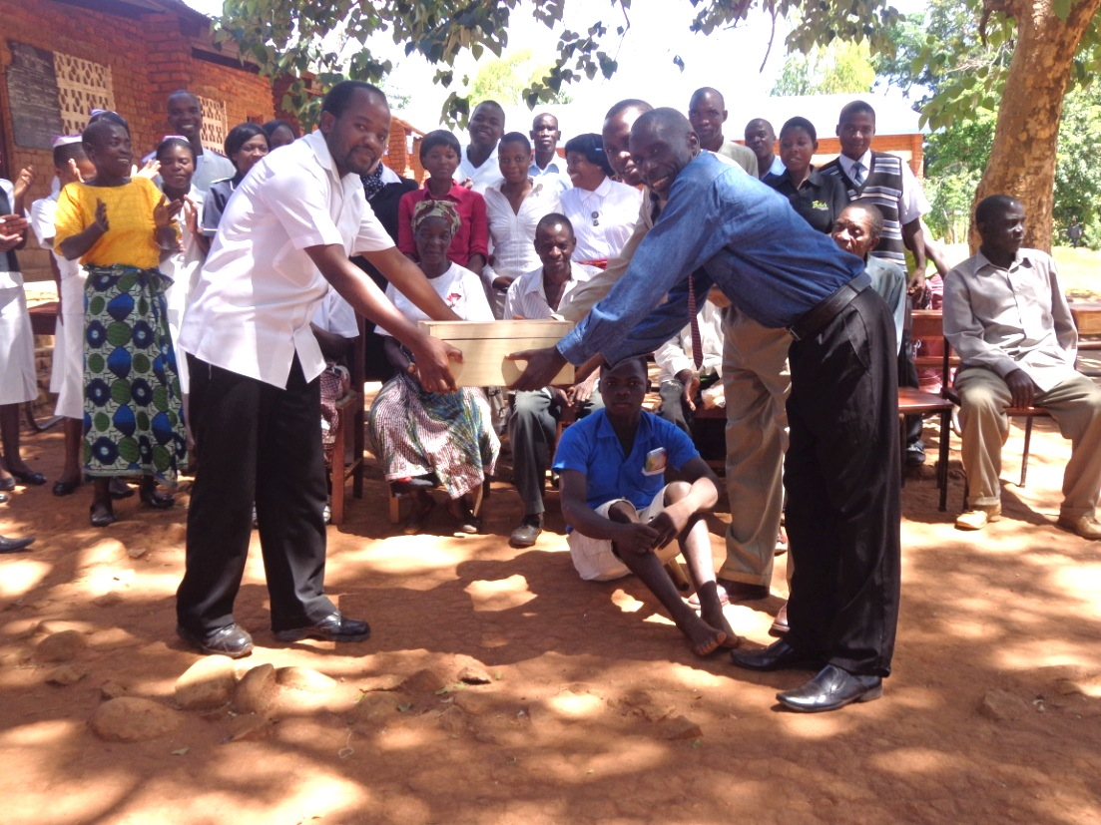
Figure 3 Handing over a drug box to the headmaster

- First aid treatment should be given to pupils when in need.
- Health Surveillance Assistants should provide chlorine to be used when cleaning the toilets.
- Use of protective wear like gloves, aprons and facial masks when cleaning the toilets.
- Counselling on body hygiene and giving breakfast to pupils was done to parents who came
- Treatment was given to pupils who had fever, abdominal pains and headache and wound dressing was done to pupils who had wounds.
- All HIV positive pupils were verified through their parents that all are on ART.
- Health education on proper cleaning of teeth and to avoid eating sweets and biscuits to prevent tooth decay was done. Parents were advised to buy tooth brushes for their children
- Those with major ailments like severe tooth decay, extra teeth, large wounds were referred to hospital for further management.
- The school ground should be slashed, remove stones and levelling to prevent accidents.
- General hygiene of the school premises including school markets should be re inforce by the headmaster and teachers.
- LONG TERM SOLUTIONS
- The headmaster assured the group that he will continue to lobby for learning materials to improve their teaching standards.
- The headmaster assured the group that he will continue to lobby for more teachers and also to balance the gender among the teachers.
- The school management and the community should find ways of finding desks, doors for the toilets and building teacher’s houses from the education authorities and other stakeholders

11. NUTRITION

Months | NRU  (severe malnutrition) |  | Supplementary  (moderate malnutrition)
 | 2012-2013 | 2013-2014 | 2012-2013 | 2013-2014
July | 5 | 3 | 13 | 5
August | 3 | 1 | 13 | 18
September | 7 | 6 | 15 | 7
October | 6 | 4 | 18 | 14
November | 7 | 2 | 7 | 18
December | 5 | 3 | 12 | 10
January | 11 | 5 | 15 | 21
February | 8 | 5 | 20 | 15
March | 7 | 7 | 13 | 15
April | 7 | 8 | 14 | 29
May | 2 | 8 | 7 | 12
June | 2 | 4 | 5 | 12
Total | 70 | 56 | 152 | 176

FOOD SECURITY
This is a section of PHC that looks at availability food in households mostly those that are vulnerable. In this reporting year the following were activities that were done to achieve this objective
- 27 Volunteers were identified to receive daily goats and so far 16 livestock kraals have been constructed and 5 people have received daily goats.
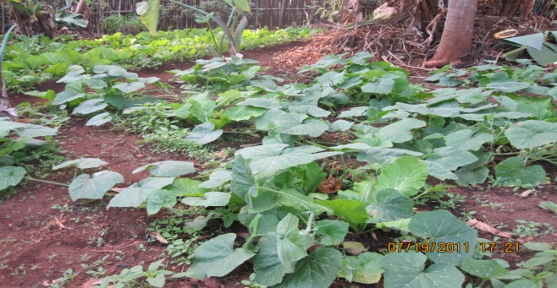
- 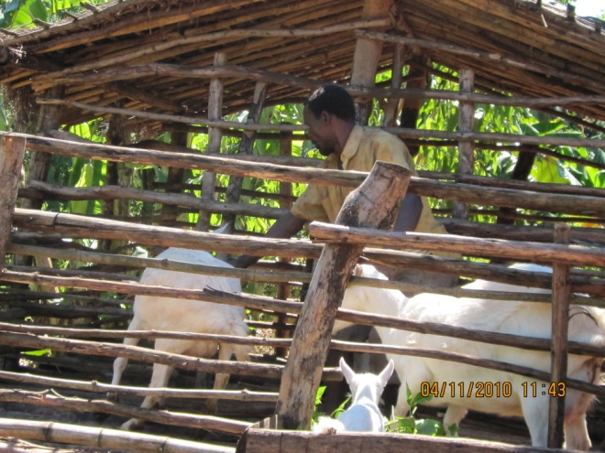
- Maintenance of NRU garden fence was done and assorted crops were planted
- 200 kitchen gardens were established and 90 watering canes distributed
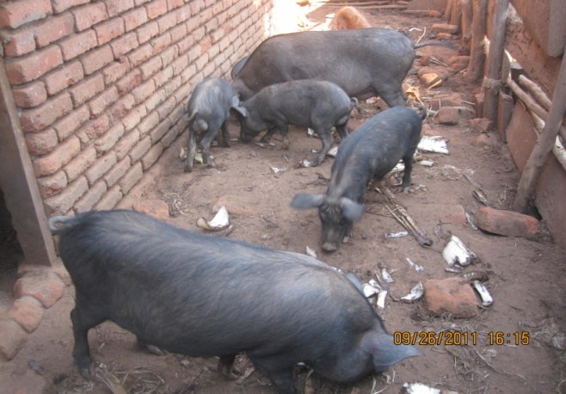
- 39 beneficiaries were trained on the modern methods of Agriculture and 30 farmers on permaculture. In addition 300 farmers were trained on how to transplant seedlings, how to make composite manure, brick rocket stove and animal management.
- 22 livestock kraals were constructed on which 22 pigs were procured and distributed to PLWAs

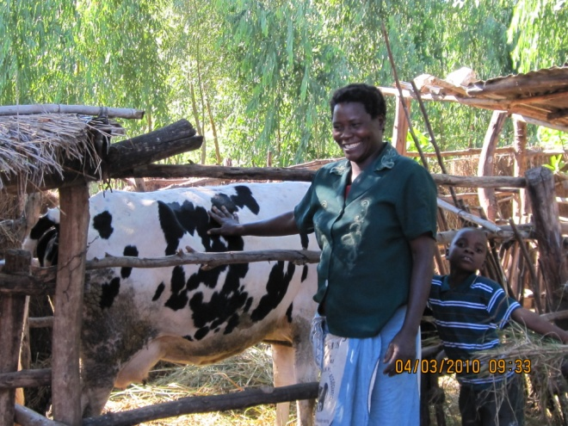

- One cow was procured and given to Mrs. Chiocha of MMamela village under safe motherhood project project
- An orchard was established behind NRU building and the following fruits were planted: oranges, Mangoes, Bananas, avocado pears sweet apples and paw paws.
- Detailed programme statistics are available in Appendix One.
- CHALLENGES
- So far there were no big problems relating to the food security program but there is need of a computer in the office where data can be safely kept collected from the field.
- ACHIEVEMENTS FOR THE CURRENT YEAR
- NRU garden fence was constructed and varieties of crops were grown.
- 400 beneficiaries were trained on the making of composite manure and 69 trained on the modern methods of farming, making of rocket stoves.
- 200 kitchen gardens were established where different crops were planted
- 90 watering canes procured and distributed to be used at the beneficiaries garden and at the community garden
- Two orphan student from chambe Community Day Secondary School were paid school fees from mwanamvula community garden.
- Beneficiaries from Tambala Community Garden have generated MK25, 00.00 for selling of fish from their fish pond.
- FUTURE PLANS
- To implement dairy cattle project at nutrition rehabilitation Unit.
- To expand fish farming to other community garden.
- Strengthening existing kitchen gardens and community gardens by closer supervision and follow up visits.
- Strengthening the existing dairy goats by constructing 27 livestock kraals and distributing the 27 goats to 27 beneficiaries.
- To expand pig project to people living with HIV / AIDS as well as daily goat to volunteers and orphaned children.
- Strengthening individual kitchen field and community gardens by closer supervision and follow up visits

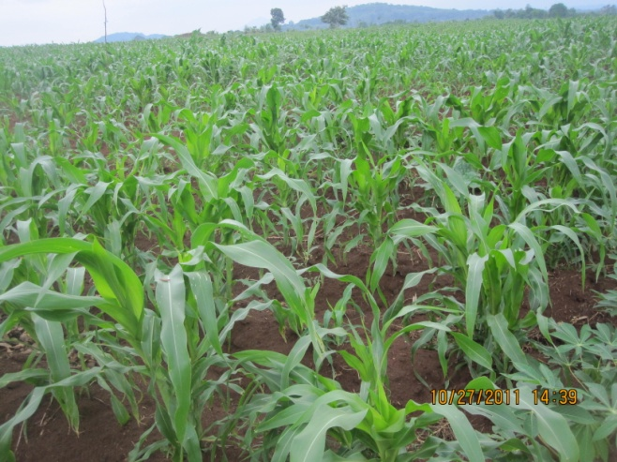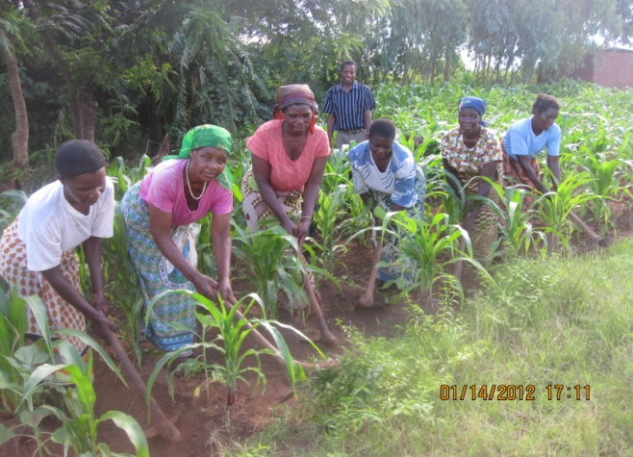

Figure 4. Felix teaching women new farming methods

12. AIDS PREVENTION, TREATMENT AND CARE

The activities of this programme aim at prevention of HIV transmission and provision of care to all that are infected and affected by HIV.

HIV TESTING AND COUNSELLING
Staffing: Currently there are 5 permanent and 2 volunteers counselors.
2013-2014 HTC and PMTCT services statistics

Number tested and given results | 12481
Number tested HIV positive | 1069
Number confirmed positive | 681
Number tested HIV NEGATIVE | 10731
Number of males tested and given results | 3553
Number of female pregnant tested and given results | 3215
Number of female pregnant tested HIV positive | 248
Number of female pregnant confirmed positive | 69
Number of female non pregnant tested and given results | 5713
Number tested with partner and given results | 1734
Number of never tested before at any site | 8763
Number tested for the first time | 3718

HTC statistics by age
0-11months | 22
1-14 yrs | 1654
15-24 yr | 4190
Above 25yrs | 6615

Achievements
- Tested 12481 clients
- 352 DBS sample were sent to QECH, 16 were found positive and 306 were negative, 30 results not out.

Challenges
- Test kits were out of stock mostly in the months of September, October and December.
- Condoms were in short supply
- Male participation is still a problem although there is little improvement from 3449 to 3553 this year.
- As counselors we are failing to understand deaf and dumb clients
- DBS results are coming late from central hospital so it making us fail to deliver result to our clients in time.

13. Home Based Care (HBC)

Community home based care helps to integrate care with HIV and AIDS education that promotes acceptance of the disease by the patients, family members and community as a way of preventing HIV infection. It also reduces stigma and discrimination to the patients from family members and the community because both parties aims at supporting the patients.
Community home based care promotes long term family support and strengthening of family-community bonding, it is a family’s responsibility to make sure that the patients are being taken care of and support them physically by bathing them or taking them in and out of the house also supporting these patients emotionally by sharing with them the word of God even sharing with them some other stories just to make them feel accommodated.

Capacity building:
Capacity building is one of the components that improves quality assurance in providing health services to the community, especially issues to do with HIV and AIDS. For the past year we didn’t have any training regarding home based care for health providers, but a refresher course was conducted for 60 volunteers

Service delivery:

 | Male | Female | TOTAL
New patients | 24 | 39 | 63
Old patients from 2012 - 2013 | 9 | 19 | 28
Bedridden patients | 14 | 21 | 35
Deaths | 9 | 12 | 21
Nutritional support | 8 | 11 | 19
Patients who received nutritional support | 3 | 7 | 10

14 . HIV & AIDS, POSITIVE LIVING TRAINING FOR SUPPORT GROUPS

Introduction.

This report provides an overview of what transpired during a three day support group training which was conducted on 12th - 15th February, 2014 at the PHC training centre. 30 participants were invited.

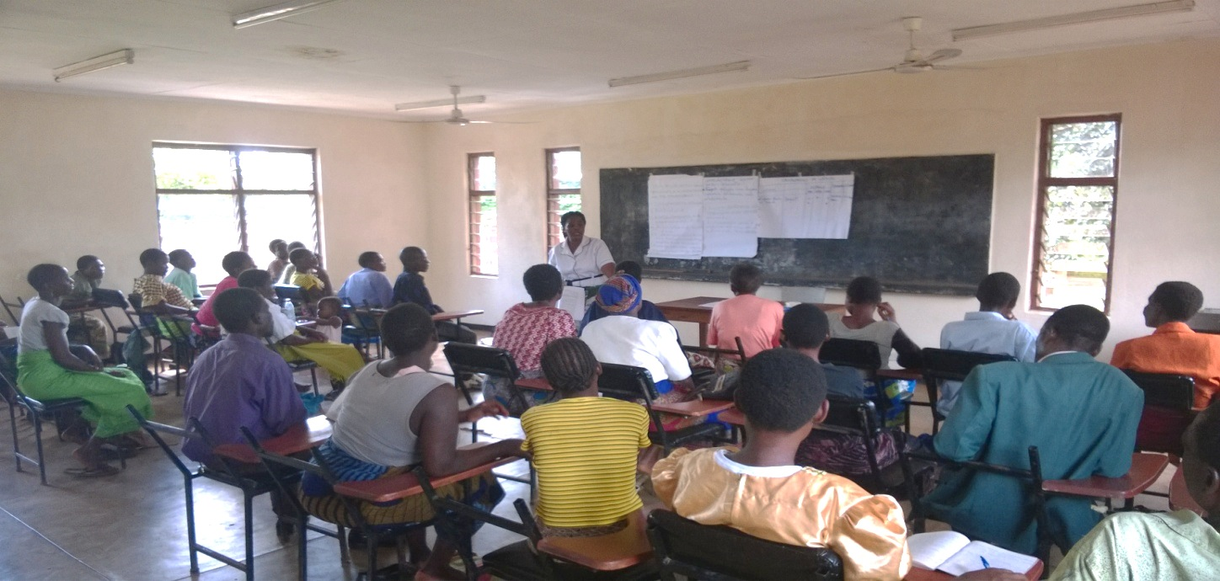
- Figure 5 Training in progress
Main objective.
The main objective of the training was to train support group members on positive living and leadership skills.
Overall Objective.
To impart knowledge and skills on how to live positively also on how to run support groups in various communities
Structure of the training.
The training was conducted in the morning for discussions and in the afternoon it was practical work for the trainers. On the last day of the training it was for designing action plan that trainers will be following in the next three months. Five trainers facilitated the training, three community nurse from PHC and HIV and AIDS coordinator.
Expectations.
In this training support group members were expecting the following:
-To upgrade their knowledge on positive living skills and leadership skills
-To know some other teaching methodologies
-To know other health services that are relevant to them.
- Guidance and counselling

- Units covered
- Defining support group
- How to run support groups
- Support group meetings
- NAPHAM programs and duties of support groups
- Identifying and analyzing support group programs
- Report writing
- Networking and linkage with government and other organizations.

- Lesson learnt from the traning.
- Lack of knowledge, especially on how to run support groups
- Documentation and report writing.
- Discrimination from the community.
- Men living with HIV and AIDS not participating in support groups.
- Inadequate leadership skills.
- Income generating activities not being done to support the running of support groups, also individuals.
- Challenges:
- Lack of training manuals both for Chichewa and English version.
- Training period was very short.

- Recommendations:
- Regular supervision to monitors all programs conducted by support group hence motivate them.
- To conduct more trainings and attract male participation.
- To encourage exchange visits among support group and learn from each oth

- 15. PLWA clinic
This is a clinic that is conducted twice a month to assess people who are living with HIV. Some clients are assessed once a month while others are assessed twice depending on their clinical presentation. PLWAs are encouraged to attend this clinic so that their health status is monitored. The following are the services that are offered
Health education
Weighing
Screening
Distribution of Likuni phala and Chiponde
Ongoing counselling
Preventing Mother to Child transmission
During the year the following attended the clinic
Pregnant women 321
Lactating women 40
Children tested at 12 months and found reactive 7
Children tested at 12 months and found non-reactive 697
PLWA 863

16. ORPHAN CARE AND TRAINING CENTRE

To promote awareness and use of the Orphan Care and Training Center among members of the community, the following activities took place:
- Educational talks about the center were given at all gatherings and in all trainings conducted by the PHC department.
- All children registered under the program received free medication when sick.
- Networking with the district hospital for referral of orphaned babies

As a result of the above measures we saw a decrease in the number of children dropping out and admitted to hospital, as well as reduced deaths as shown in table below:

 | 2013-2014
Number of new admissions | 35
Drop outs and discharges | 0
Deaths | 1
Number referrals for treatment | 102
Number admissions in hospital | 1
Total orphans in program | 138

Other activities done
- Cooking demonstrations
- Education about a home garden and provision of a starter pack were given to guardians
- Supply of Lactogen to all babies aged 6 months and below
- Supply of Likuni Phala to all children over 6 months
- Follow up of babies
- General health education

17. YOUTH PROGRAMS
- This report highlights the activities that have been undertaken by the youth centre for the past year. The activities are all done on voluntary basis by the youth centre volunteers. In brief Mulanje Mission youth centre was established in April 2003 as a response to the call by the National youth council of Malawi and Malawi government through Project Hope to all stakeholders in the health sector to embark on the provision of youth friendly heath services. This was geared towards addressing health problems young people are facing in country as well as the catchment area.
- Its mission is to provide the youth in the catchment area with comprehensive sexual and reproductive health services in a youth friendly environment regardless of gender, colour, religion and creed. Its vision is to have youth friendly health services that empower young people to identify and seek health services when needed.

See Appendix Two for list of Registered youth clubs and membership

Achievements
A general meeting was conducted to discuss the stand of the youth centre where by all youth club chair and secretary attended. Out this meeting general issues agreed were,
- Drafting of 2014 - 2015 action plan
- Supervision of youth clubs
- Adding more youth clubs members to the old executive committee
- Conduct manual work at the centre every month.
- Registration of youth center under the DYO.
- All youth clubs have registered under District youth office
- The condom distribution is going on well

Challenges
- Inadequate life skills training and vocational skills.
- Drop out of youth club members
- Replacement of recreation materials e.g. pool table,
- Low girl participation both at youth centre and youth club level.
Way forward
- To introduce vocational training centre and farming business skills to young people.
- Open up computer lessons for young people in the catchment area.
- To continue offering life skills trainings to young people.
- To have a well stocked vocational centre for the young people.

18. PALLIATIVE CARE ACTIVITY IN 2013-14
The Palliative care programme has had a busy year. Mr Mpate has moved on to a new post, and two further members of MMH staff will be going to the Institute of Hospice and Palliative Care in Uganda for further training in this speciality.

2013-14 | Male | Female
Number of new patients who received palliative care | 44 | 64
Number of subsequent patients who received palliative care | 85 | 111
Number of patients who were reached through hospital ward visits | 171 | 178
Number of patients who were reached through home visits | 37 | 50
Number of bereavements visits made | 24 | 21
Number of patients received psychosocial support | 8 | 9
Number of death in the year | 29 | 28
Total number of patients provided with HIV related palliative care including TB and cancer | 72 | 57

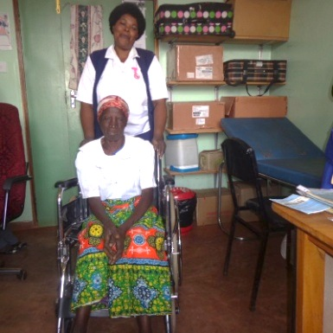
Palliative Care patient with Ethel Misomali, palliative care nurse at MMH

4. Common conditions
In adults, conditions treated included kaposi’s sarcoma, ca cervix, ca oesophagus, basal cell carcinoma, and lymphoma as well as patients with severe strokes. In children, conditions included tumours and congenital heart disease.
5. Drug availability
Level One and level Three drug supplies were available all year, but some level 2 drugs (tramadol) were not always available.

Total number of patients who received pain relief in last quarter | male | female
 | 137 | 139
Total number of patients who received oral morphine in last quarter | 22 | 38

Conclusion
The PHC team is busy doing a lot of things both at the hospital and in the community, which is helpful for individual and community development. We are thankful to all our donors for making this possible.
PHC Dept
July 2014

